**Experiment-8 Understanding DHCP networking using CLI**

ECP316 (Communication Networks)

**Aim:** Understanding the DHCP network in Cisco Packet Tracer using CLI.

**Tools Used:** Cisco Packet Tracer

**Theory:**

**Dynamic Host Configuration Protocol (DHCP)** is a network management protocol used to automatically assign IP addresses to devices on a network. It eliminates the need for manual IP configuration, reducing errors and administrative overhead. DHCP operates using a client-server model, where the DHCP server dynamically allocates IP addresses, subnet masks, gateways, and DNS settings to requesting clients.

The process involves four steps: Discovery, Offer, Request, and Acknowledgment (DORA). DHCP enhances network efficiency by ensuring optimal IP utilization and preventing conflicts. It is widely used in enterprises, ISPs, and home networks to simplify IP management and ensure seamless connectivity.

**Procedure:**

1. Open Cisco Packet Tracer application on computer.
2. Use 2 sets of PCs under either single router or 2 as network 1 and 2.
3. Use PT Router and Switch only as they’re already defined according to our use.
4. Use RJ45 Cables to connect the PCs and switches as according to the topology diagram. We can check the connections using ping in the command prompt of each PC.
5. Try sending mail from one PC to another in both cases and start simulation and observe.
6. Try Sending on different paths like 1st router sub-PC to 2nd router sub-PC etc..

**Connections:**

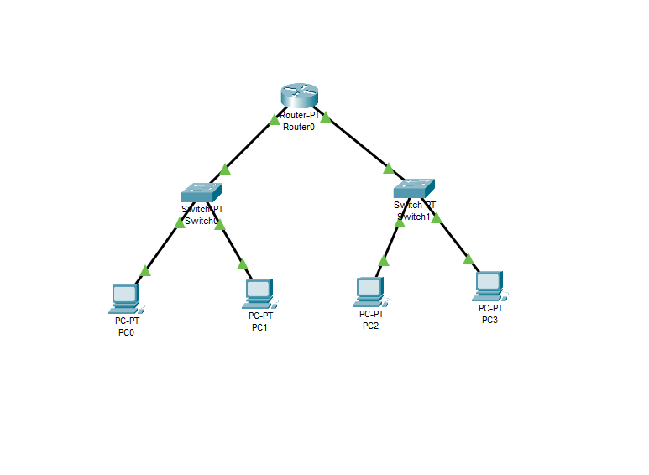

**CLI Commands:**

* Router>**en**
* Router#**configure**
* Configuring from terminal, memory or Network(terminal]?**terminal**
* Router(config)#**int fa0/0**
* Router(config-if)#**ip address 192.168.1.1 255.255.255.0**
* Router(config-if)#**no shut**
* Router(config)#**do write memory**
* Router(config)#**ip dhcp pool net1**
* Router(dhcp-config)#**default-router 192.168.1.1**
* Router(dhcp-config)#**network 192.168.1.0 255.255.255.0**
* Router(dhcp-config)#**exit**
* Router(config)#**int fa1/0**
* Router(config-if)#**ip address 192.168.2.1 255.255.255.0**
* Router(config-if)#**no shut**
* Router(config)#**do write memory**
* Router(config)#**ip dhcp pool net2**
* Router(dhcp-config)#**default-router 192.168.2.1**
* Router(dhcp-config)#**network 192.168.2.0 255.255.255.0**
* Router(dhcp-config)#**exit**
* Router(config)#**exit**
* Click on PC Desktop IP configuration → **select DHCP**
* **IP address will be assigned to all Pc dynamically**

**Assigned IPs:**

**Network set 1:**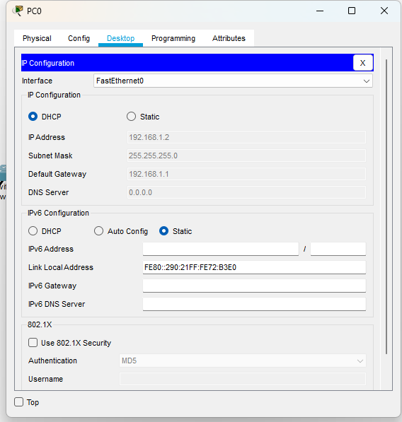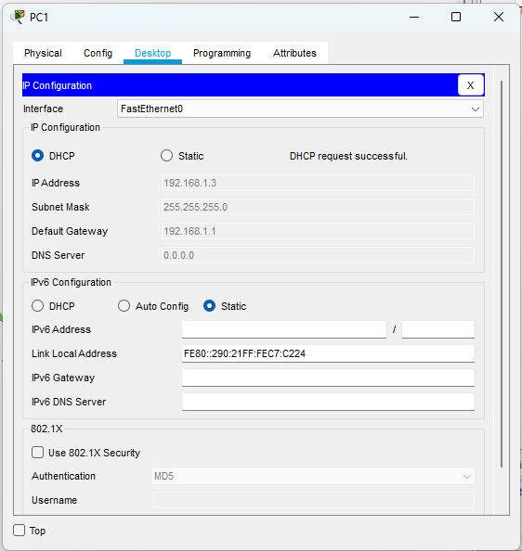

**Network set 2:**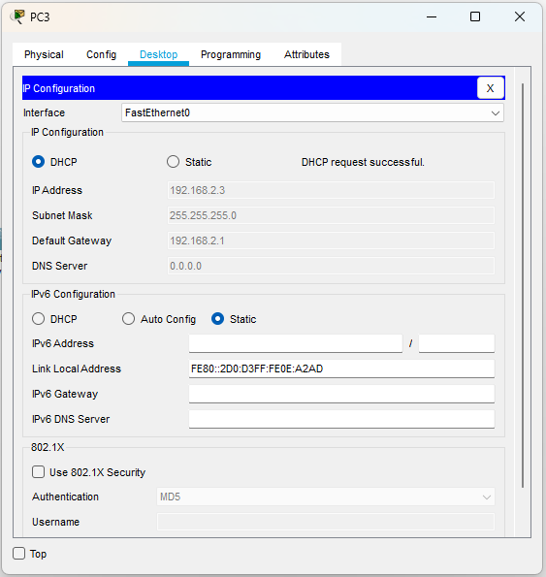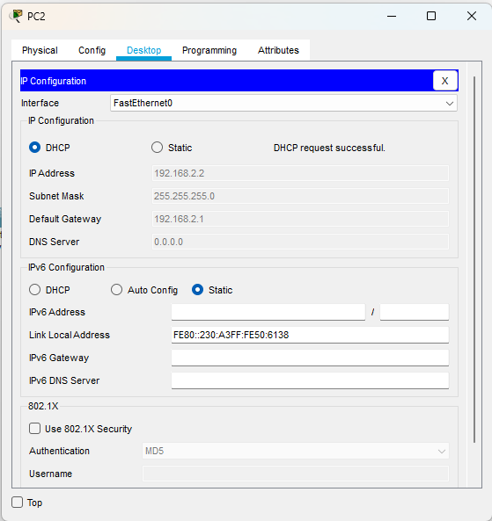

**CLI:**

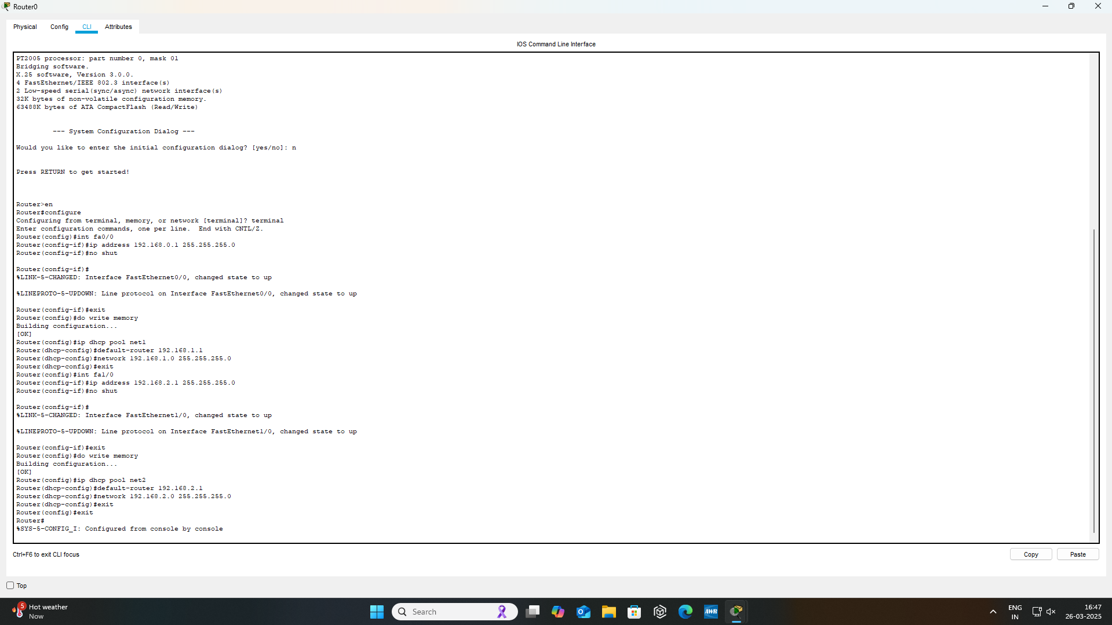

**Testing on Routes (Simulation):**

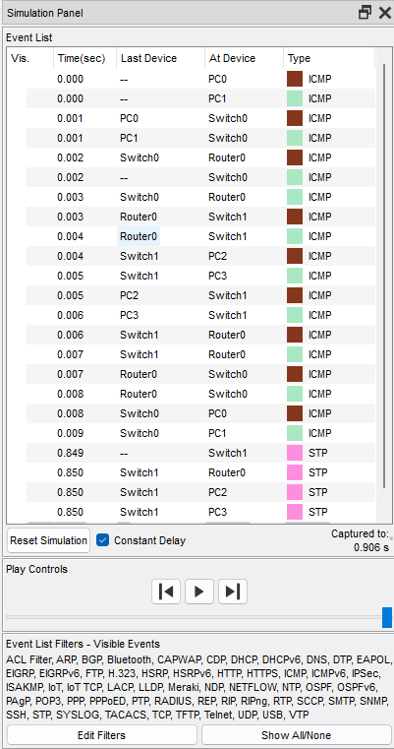

**Success:**

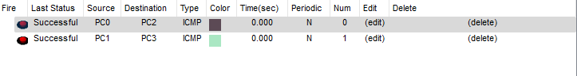

**Result:**

In the experiment with two network sets, the **DHCP server successfully assigned** IP addresses dynamically to devices in both networks.

Each network received appropriate IP configurations without conflicts, ensuring seamless communication. This demonstrated **DHCP’s efficiency** in managing multiple subnets, reducing manual configuration effort, and optimizing IP address allocation.

**Conclusion:** The experiment demonstrated **DHCP’s effectiveness** in automatically assigning IP addresses across multiple networks.

It ensured seamless communication, prevented IP conflicts, and reduced manual configuration efforts.

DHCP efficiently managed different subnets, proving its **importance in large-scale networks for dynamic IP allocation**, improved network management, and enhanced operational efficiency.